Github

<https://github.com/buruguchandana27/ICP1.git>

1. Write a python program for the following: – Input the string “Python” as a list of characters from console, delete at least 2 characters, reverse the resultant string and print it.

Sample input:

* + python
  + Sample output:
  + ntyp

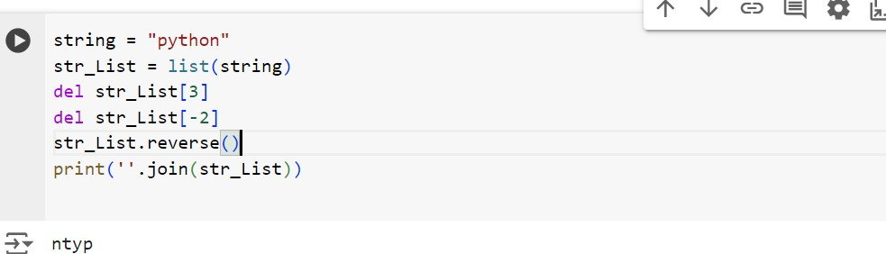

Taken string python as input into the list delete the string in list and reversed the string and join them by using join function

Take two numbers from user and perform at least 4 arithmetic operations on them.

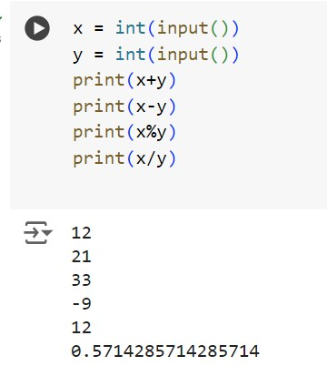

Taken two numbers as input and performed 4 operations

1. Write a program that accepts a sentence and replace each occurrence of ‘python’ with ‘pythons’. • Sample input:

•I love playing with python

* + Sample output:

•I love playing with pythons

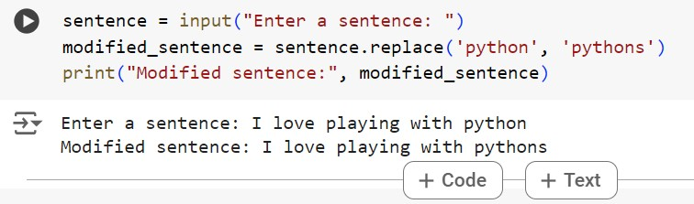

Taken a sentence as input and modified every python word as pythons by using replace

1. Use the if statement conditions to write a program to print the letter grade based on an input classscore. Use the grading scheme we are using in this class.

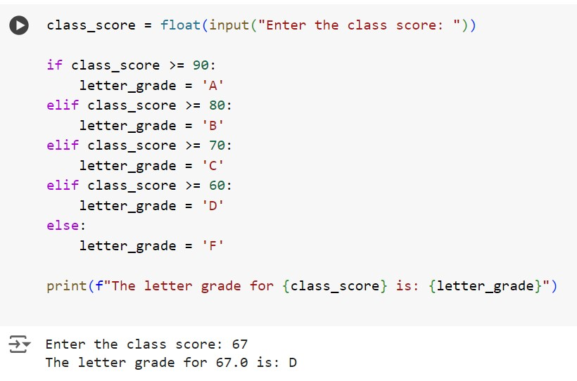

Taken one score and graded that score by using the elif